Contribution Report

Jeremy P.R Paruch
Department of IT: Programming, Nova Scotia Community College
INET 2005/Web Application
Nadia Gouda
December 12, 2025

Table of Contents
Contribution Report 4
Dawson: 4
Josh: 4
Judah: 4
Jeremy: 4
Tasks Completed 5
Dawson: 5
Dec 05 5
Josh: 5
Dec 02: 5
Dec 03: 5
Dec 05: 5
Dec 05: 5
Dec 05: 5
Judah 5
Dec 03: 5
Dec 04: 5
Dec 05: 5
Dec 05: 5
Dec 05: 5
Dec 08: 5
Proof of Contributions-Josh 6
Josh 6
Proof of Contributions-Josh Continued 7
Proof of Contributions-Judah 8
Proof of Contributions-Judah Continued 9
Proof of Contributions- Dawson 10
Proof of Contributions-Jeremy 11
Proof of Contributions-Jeremy Continued 12

Contribution Report

Dawson:
Primary:
Backend Developer
Secondary:
Speaker

Josh:
Primary:
UI Font End Developer
Secondary:
QA Tester:

Judah:
Primary:
Back End Developer
Secondary:
Bug catcher

Jeremy:
Primary:
QA Testing & Documentation | Scheduler
Secondary:
Back-End Developer

Tasks Completed

Dawson:
Dec 05 Assisted Back end Testing (Fixed testing issue utilizing Frankensteining) code from other project).

Josh:
Dec 02: Front end development established
Dec 03: Table for books established, Thyme leaf implemented, small changes to CSS, Main Branch was merged.
Dec 05: Updated redirected register page
Dec 05: New version of project created because 4.0.0 of spring was causing issues with dependencies, removed old project for the new version
Dec 05: Random numbers showing up on the login card, josh removed

Judah: Provided Backend logic control
Dec 03: Handbook uploaded to GitHub, uploaded skeleton of classes, main branch was merged
Dec 04: working prototype created
Dec 05: Configured loading books into the repository.
Dec 05: Edited email parameters, Merged Main branch

Jeremy: Assisted with CSS, implemented validations,
Dec 05: Implemented jarkata validations
Dec 08: Edited and pushed CSS for home page, additional validation added, but then removed. Woops!. Documentation, pptx, drafted

Proof of Contributions-Josh

Josh
Figure 1:Proof of Josh's Contribution
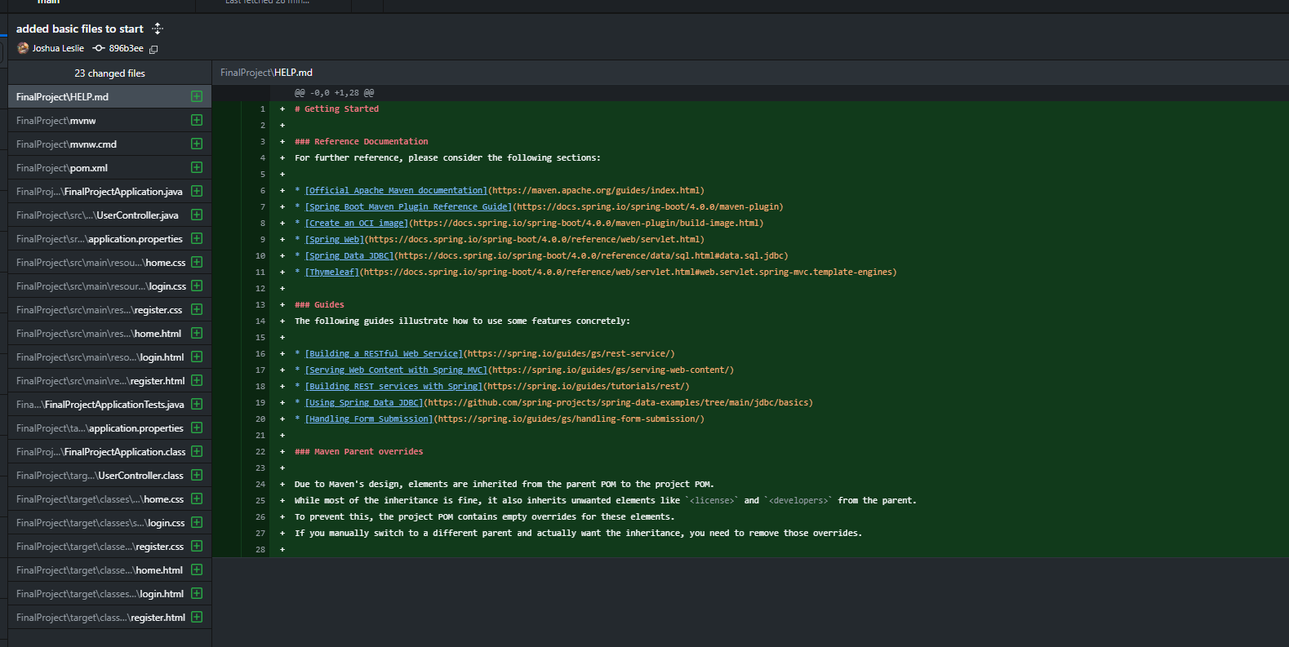

Figure 2:Proof of Josh Contribution Part 2
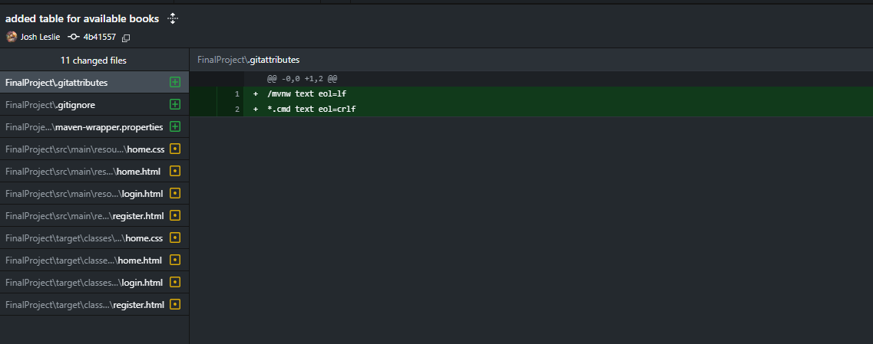

Proof of Contributions-Josh Continued
Figure 3:Proof of Josh Contribution Part 3
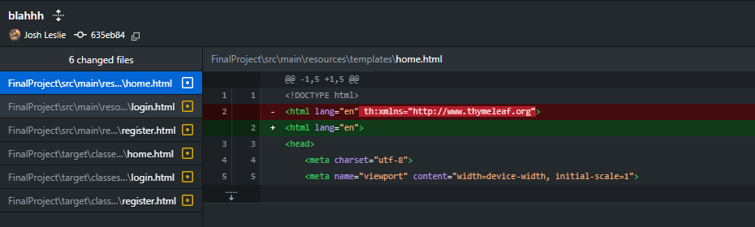
Figure 4:Proof of Josh Contribution Part 4
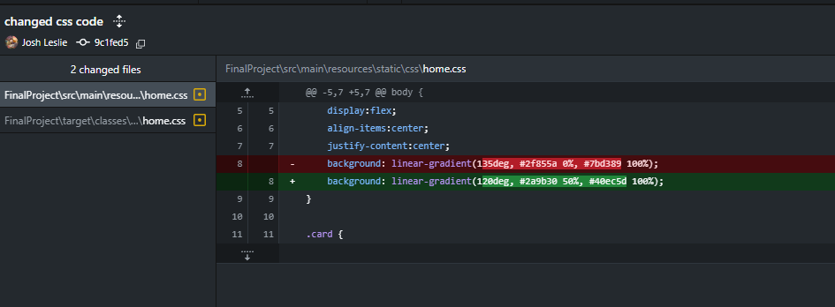
Figure 5:Proof of Josh Contribution Part 5
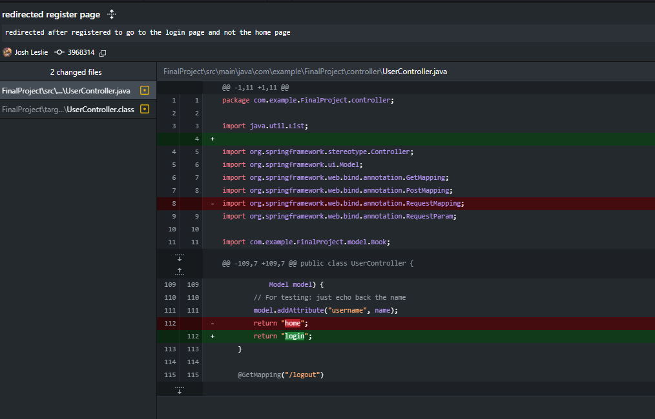

Proof of Contributions-Judah

Figure 6:Proof of Judah Contribution
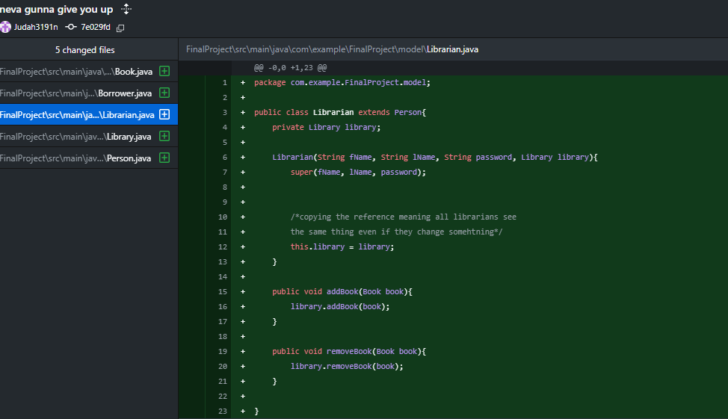

Figure 7:Proof of Judah Contribution Part 2
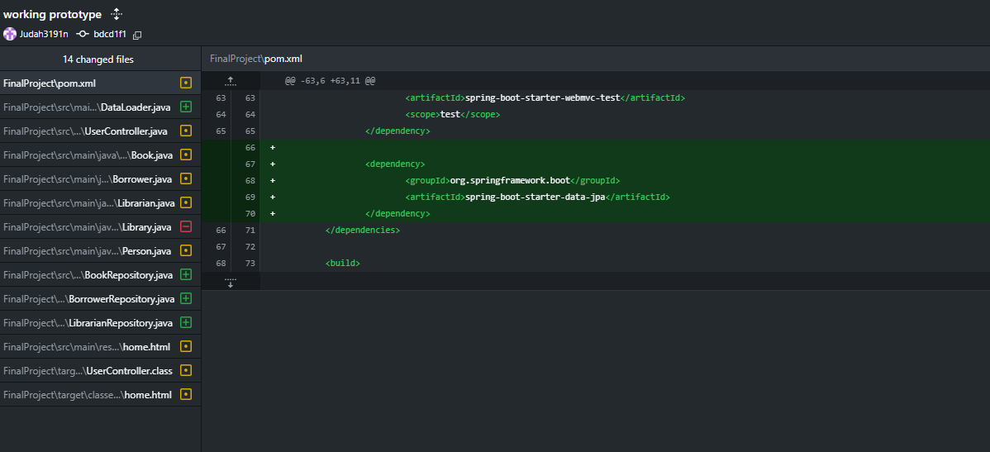

Proof of Contributions-Judah Continued
Figure 8:Proof of Judah Contribution Part 3
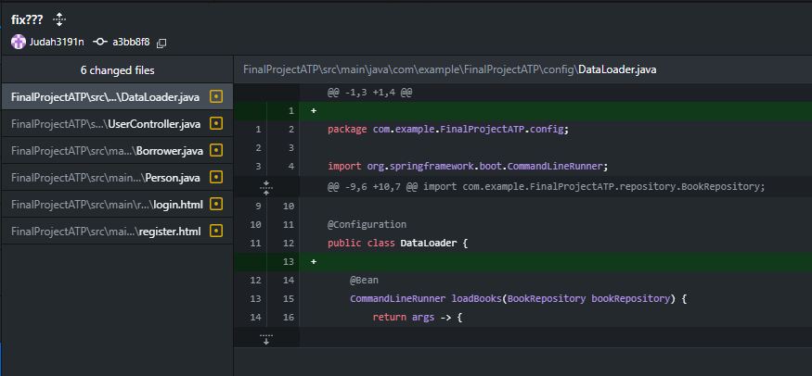

Proof of Contributions- Dawson
Figure 9: Proof of Dawson Contribution
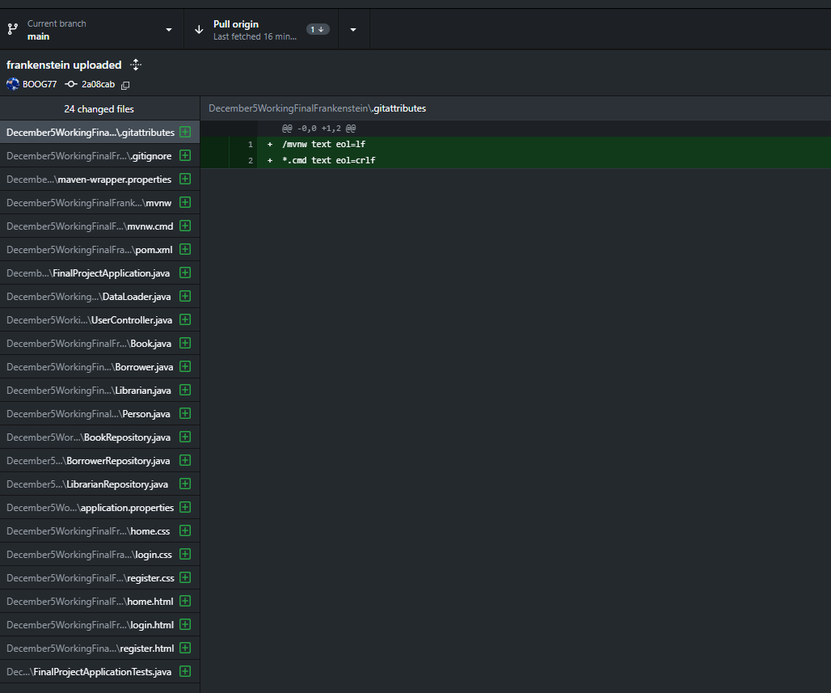

Proof of Contributions-Jeremy
Figure 10:Proof of Jeremy Contribution
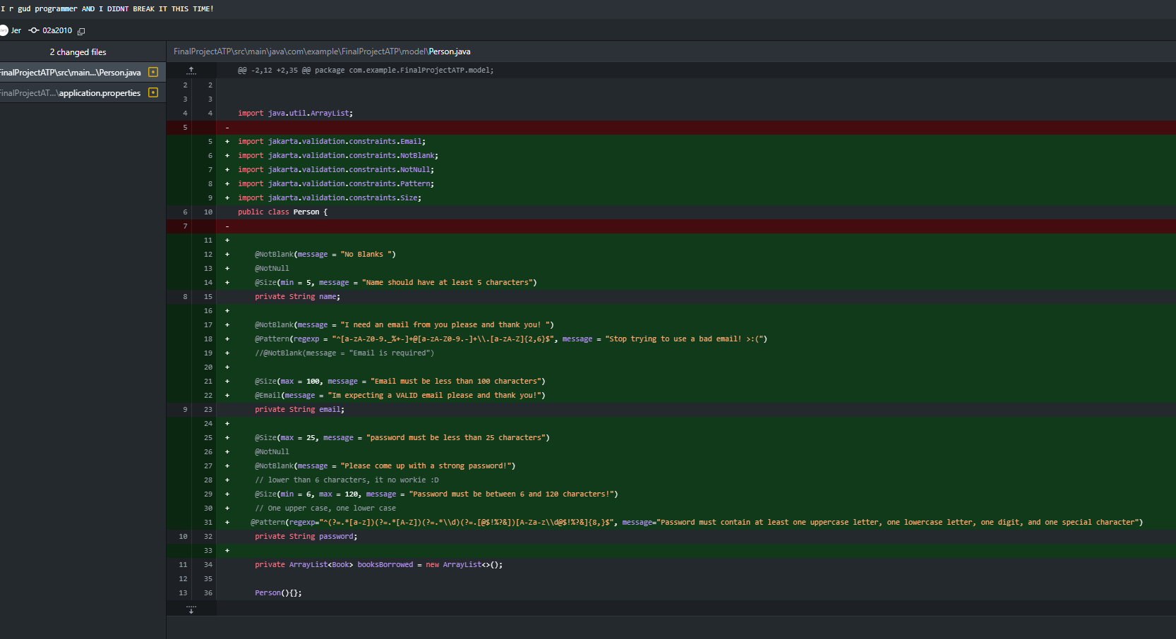
Figure 11:Proof of Jeremy Contributions Part 2
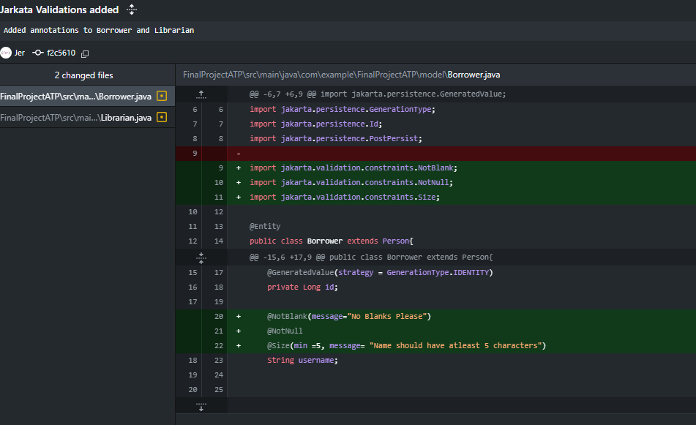

Proof of Contributions-Jeremy Continued
Figure 12:Proof of Contributions Jeremy Part 3
